Our Place Preschool

Family Handbook

53 Stockton Street
Nelson Bay 2315
Landline:02 4024 2558
E: jan@ourplacepreschool.com.au
www.ourplacepreschool.com.au
ABN 55 603 370 190

Owner/ Director/ Licensee – Jan Slade

Operating Hours are from 7.30am-5.30pm
51 weeks of the year
Closing between Christmas and New Year

Welcome to Our Place Preschool.
You have made the best choice for your child’s Early Childhood Education.
Our Place Preschool is owned and operated by Jan Slade.
Jan has been working with children both personally and professionally, from a variety of backgrounds and childcare service types for the past 25 years.
Our philosophies are based on honesty, integrity, professionalism, and most importantly family values,
Play based learning and family and community involvement is at the core of all that we offer.
Our Place Preschool Mission

Our Place Preschool is an inclusive service that implements
child initiated play based learning based on the
Early Years Learning Framework.
Our focus is for families, educators, management, and the community
to develop strong partnerships to provide every child the opportunity
to reach their full potential at their own pace,
in a child safe environment.
Family Community, and Belonging.
Commitment to Child Safety
At Our Place, we are committed to providing a child safe environment. We are trained in child protection and understand our roles and responsibilities as mandatory reporters. Our Place was purposely designed with large open spaces with clear visibility indoors and outdoors. Our policies, practices and risk assessments are reviewed as regulations are updated and/or yearly.
All of our regulation policies are readily accessible to families via our OWNA app, and we have a folder containing all of our policies at the children’s locker area.
As part of our Child Safe practices, Each Employee of Our Place Preschool is screened through working with children checks, reference checks, Formal interview processes, trial periods and an extensive induction checklist to ensure their suitability for our child safe environment. We have continuity of educators. Continuity of care provides significant benefits as children thrive in stable, nurturing environments with consistent known educators, leading to stronger attachments, smoother developmental progress and a greater sense of security encouraging each child to develop their sense of wellbeing and belonging.
Our roster is available for families on our OWNA app, this is a great addition as this enables all families to know who will be caring for their child each day.
We kindly ask all visitors & families to refrain from entering Our Place with any recording device as we respect each childs right to privacy. This includes but not limited to cameras, phones, and video cameras.

OWNA
We communicate with families through OWNA which provides a secure, private, fun and cost-effective way for child care educators to document & share with family through real-time updates. The benefits for families are as follows:
~ Parents receive updates via the free app all in real time!
~ Family members can continue the learning with their children at home creating a continuum of care
~ Securely invite additional family members worldwide to view your child’s OWNA, its free and so is the app!
- Please note upon enrolment each family has the choice for if they would like their child to be apart of group photos shared on OWNA.
All updates are uploaded to OWNA using service issued devices only.

What Your Child Will Need Throughout Their Day
A backpack or bag clearly marked with your child’s name that contains the following necessities:
- Several spare changes of clothes including underwear
- Nappies and pull ups adequate to meet your child’s daily needs
- Hat with a wide brim (no caps for sun safety)
- Clothing suitable to ensure sun safety
- Swimmers and Sun shirts (we do a lot of water play)
- Footwear especially if we are going on excursions
- Lunch box packed with morning tea, lunch, and afternoon tea. Please try to be in line with National Dietary Guidelines for children this age. We have support information available if you require it.
- Water will be available indoors and outdoors for the children to access, but they may prefer a drink bottle (water only)
- Please ensure all belongings are clearly labelled with your child’s name on it, this will assist us to ensure property is not lost.
- We will supply sunscreen at regular intervals throughout the day. However, if your child has an allergy to sunscreen please make the educators aware and supply the appropriate type that is safe for your child to use.
- A comfort item/ blanket if you feel your child may need it please make staff aware.
What NOT To Send With Your Child
- Toys from home- they often cause arguments or could be broken. We have plenty of resources that can be used and shared between all children.
- Medication in their bag. If they require medication please give to educators on arrival and they will secure it safely and get you to fill in the required documentation. This includes asthma inhalers.
- Best clothes- children need to be comfortable in what they play in and not scared to get wet or paint on them, old clothes that wash well are best. As part of your enrolment fee you will receive a Shirt and Hat this is perfect to wear.

Medication
All medication must be in original container, clearly labelled and prescribed by a doctor with your child’s name, dosage, and frequency on it. It also needs to be within use by date. Hand it to educators and complete documentation prior to departing, Information can also be documented on the OWNA app.
Over the counter medication can not be administered by educators.
Fees
- There will be a one off Enrolment fee of $70/ child. Additional siblings will be charged at a rate of $50/ child. Upon receipt of the enrolment fee your child will be asked to select a preschool hat and shirt, we encourage the children to wear their shirt and hat as they are chosen to be serviceable in a preschool setting. Please clearly label clothing.
- Fees are to be paid 1 week in advance, talk with the director upon commencement and a fee estimate can be done for you.
- Our service is dependent upon families paying their fees promptly and on time. We aim to keep costs to a minimum and offer many excursions and incursions as part of your fee. If you are experiencing difficulty please speak with the Director and arrangements can be made. If fees fall in arrears by 2 weeks then you may risk termination or reduction of care.
- In the event that your child is unwell or on holidays you are still required to pay the normal fees. We appreciate you letting us know as soon as possible if they are going to be away.
- Our Place Preschool operates 51 weeks of the year closing between Christmas and New Year, Families are not charged a fee during this closure.
- Fees can be paid to:
Act Name: Our Place Preschool BSB: 112 879
Act Number: 477 652 698
- Late Fee: There will be a charge of $15/ 10 minutes beyond 5.30pm

Settling Your Child into The Centre
We aim to support families to make their child’s transition into Our Place Preschool as smooth and trouble free for the children and families as possible.
We encourage you to bring your child to the service prior to commencing as often as you wish, and stay with them to allow them to become familiar with the educators, the indoor and outdoor areas, toilet facilities, and routines.
We find that a good orientation, at least two or more visits at various times throughout the day works best. However we understand that not everyone is able to do that but you are welcome to if you wish.
On the day your child finally commences care we ask that you make educators aware it’s their first day so they can support your child with separation. It’s important that you stay for a brief period to settle them in (10 minutes maximum) then say goodbye and leave. The longer you stay the more difficult it becomes for the child. Our educators are skilled at caring for new children and supporting them through the process.
Most children have some separating challenges at some stage. Many will be upset on commencement, but others will start smoothly and struggle about 6 weeks into the care. This is perfectly normal. If you have concerns speak with one of the educators and they can suggest some strategies. You are always welcome to give the centre a call to check on your child, and if they are too distressed we will call you. On their first days you could try picking up a little earlier so they aren’t seeing other children being picked up and worrying when they will be collected.
If you would like to spend extended time with your child in the care setting please do it either prior to commencing during orientation, or at the end of their day (come a little earlier). In our experience the longer you stay at drop off time in those first few weeks the more challenging separating becomes.
Make educators aware if your child normally has any routines for toileting, sleeping, resting, and settling, or a favoured comfort item that educators can use if required.
We love seeing extended family and grandparents so please encourage their participation.
Arrival and Departure
The following guidelines must be adhered to at all times to ensure the safety of all children:

Arrival:
- It is essential on arrival that all Children are signed IN on OWNA by a parent or responsible adult. This also assists Educators/Staff in the event of evacuation of the Education and Care Service. This is the Parent/Guardian’s or Authorised Nominee’s responsibility.
- An Educator/Staff member will greet and receive the Child at all times.
- Each Child has a locker for personal belongings.

Departure:
- No Child will be released into the care of any persons not known to Educators. If Educators don’t know the person by appearance, the person must be able to produce some form of photo identification to prove that they are the person authorised to collect the child on the enrolment form.
- Parents must give prior notice where the person collecting the child is someone other than those mentioned on the enrolment form, e.g. in an emergency situation. The person nominated by the parent must be able to produce some form of photo identification.
- Children are not to be released into the care of persons not authorised to collect the child, e.g. court orders concerning custody and access.
- Parents must give prior notice of any variation in the persons picking up the child. If notice is not given, and Educators cannot contact the Parent/Guardian, the child must not be released into the care of that person.
- If the person collecting the child appears to be intoxicated, or under the influence of drugs, and Educators/Staff feel that the person is unfit to take responsibility for the child, the Educators/Staff are to bring the matter to the person’s attention before releasing the child into their care. Wherever possible, such discussion is to take place without the child being present. Educators/Staff are to suggest that they contact the other Parent/Guardian or emergency numbers from the enrolment form, inform them of the situation and request they collect the child as soon as possible. If the person refuses to allow the child to be collected by another authorised person, Educators/Staff are to inform the Police of the circumstances, the person’s name, and vehicle make/model and registration details. Educators/Staff cannot prevent a Parent/Guardian from collecting a child, but do have a moral obligation to persuade a parent/Guardian to seek alternative arrangements, if they feel the Parent/Guardian is in an unfit state to accept responsibility for the child.
- It is essential on departure that all children are signed OUT by a Parent/Guardian or Authorised Nominee as per enrolment form. This also assists Educators in knowing who has left the Service.
- An Authorised Nominee must be a minimum age of 18 years old to sign a child in or out of the Education and Care Service unless mutually agreed in writing by the Nominated Supervisor/Approved Provider and parent/guardian (see Acceptance and Refusal of Authorisation Policy).
- In the event that you are late picking up beyond 5.30pm (closing time) there will be an additional late fee applied. This is $15/10 minutes late.
- In the event that a child fails to be picked up by a parent/ nominated person the following procedure will be put into action. * All parent/ emergency contacts will be contacted, *if unsuccessful the police will be called * The responsible person will follow the directions of the police * A notification will be made to the Helpline if required.

Family and Community Participation

Our Place Preschool owners and educators live within and are actively involved in our local community. We welcome family and community participation with in our service.
Being so close to the Nelson Bay CBD we take the opportunity to do regular excursions to the local shops, community gardens, the Post Office, and parks. Parent volunteers are always welcome on excursions.
We love community groups coming into the service and sharing their skills so if you know of anyone that might be interested in volunteering we’d love to hear from you.
During the course of the year we will hold regular get togethers for the families of the service. Everyone is welcome and there is usually no cost involved. Children’s discos are usually a big hit as well as picnics in the park, or by the foreshore. It’s a great way to make new friends.
While we appreciate not everyone has time to spare and come into the service but if you would like to be involved and volunteer in the service your time would be appreciated by the educators and children.
We have a Family Input Group where we ask family members to be involved in the running of the service and to have input into the future planning and direction you would like to see the service take. The group meets once/ 6 weeks, let the Director know if this is of interest to you.

Priority of Access
Children enrolled at Our Place Preschool will be given Priority of Access in accordance to the guidelines set by the Australian Government’s Department of Social Services.
They set out the following three levels of priority, which the education and care service must follow when filling vacant places:
- Priority 1: a child at risk of serious abuse or neglect
- Priority 2: a child of a single parent who satisfies, or of parents who both satisfy, the work/training/study test under section 14 of the A New Tax System (Family Assistance) Act 1999
- Priority 3: any other child
Within these main categories, priority should also be given to the following children:
- Children in Aboriginal and Torres Strait Islander families
- Children in families which include a disabled person
- Children in families which include an individual whose adjusted taxable income does not exceed the lower income threshold (updated annually by the Australian Government) or whose partner are on income support
- Children in families from a non-English speaking background
- Children in socially isolated families
- Children of single parents
On enrolment, parents will be notified of their priority and advised that it the service has no vacancies and their child’s position is a priority 3 under the Priority of Access Guideline, it may be required that their child leave or reduce their days in order for the service to provide a place for a higher priority child.
Cessation of Care
To cease care two weeks’ notice must be given in writing to the service. If your child doesn’t attend during that two week period full fees must be paid as you are unable to claim family assistance (CCS) for absences during your two week notice period.
Grievance Procedures
We try to ensure open communication with families at all times which assists with grievances. We welcome feedback both positive and negative and look at concerns raised as an opportunity to grow and further develop Our Place Preschool. We have an open door policy at all times and families or community members are welcome to have input.
The following procedures occur when a concern is raised

Minor Complaint

- Parents are encouraged to discuss minor concerns with room leader as soon as possible.

Serious Complaint:

- Parents should immediately discuss with Approved Provider, or
Nominated Supervisor.

- Details of complaint are recorded.

- The Approved Provider or Nominated Supervisor will investigate and keep parents informed of any actions taken.

- If parents are not satisfied with the outcome a contact number for the Department of Early Childhood Education and Care Directorate,
NSW Department of Education will be given to them.

- Families are also able to make direct complaints to the regulatory authority where the complaint alleges that:
*The safety, health or well being of a child or children was or is being compromised while that child/ children is/ are being cared for by the approved education and care service.
* The relevant legislation has been contravened.
*Contact details are also displayed in the foyer and the policy folder near the family sign in area, and listed below.

DEPARTMENT OF EDUCATION
Early Childhood Education and Care Directorate
Locked Bag 5107, Parramatta NSW 2124
Phone: 1800 619 113 Fax: (02) 8633 1810 Email: ececd@det.nsw.edu.au

6. OPPS will view each complaint as an opportunity for improvement after the complaint or grievance has been dealt with we will:
- Analyse the complaint to determine if any policy or procedural change needs to be implemented.
- The approved provider will follow through to determine that complaints and grievances have successfully resolved to everyone’s satisfaction. Families will be contacted to determine if they were satisfied with the way the issue was resolved and educators will be consulted about the outcome from an operational viewpoint.

Infectious Diseases
Our Place Preschool will minimise the spread of potentially infectious diseases between children, and the Service, by excluding children, educators/staff, and visitors, who may have an infectious disease or are too ill to attend the Service.
To minimise the spread of Infectious disease between children, educators/staff and visitors, Our Place Preschool will:
- exclude from care and notify the local Public Health Unit and provide details of any known or suspected persons with any of the following vaccine preventable diseases:
  - Diphtheria
  - Poliomyelitis
  - German Measles
  - Tetanus
  - Measles
  - Mumps
  - Whooping Cough
  - Chicken Pox

If a child has not been immunised, they may be excluded from care during outbreaks of some infectious diseases, even if their child is well, depending on advice from the Public Health Unit.

Please see Recommended Minimum Exclusion Periods taken from Staying Healthy in Childcare 6th Edition
*Most common ilnesses that we see at the service and their exclusion period include:

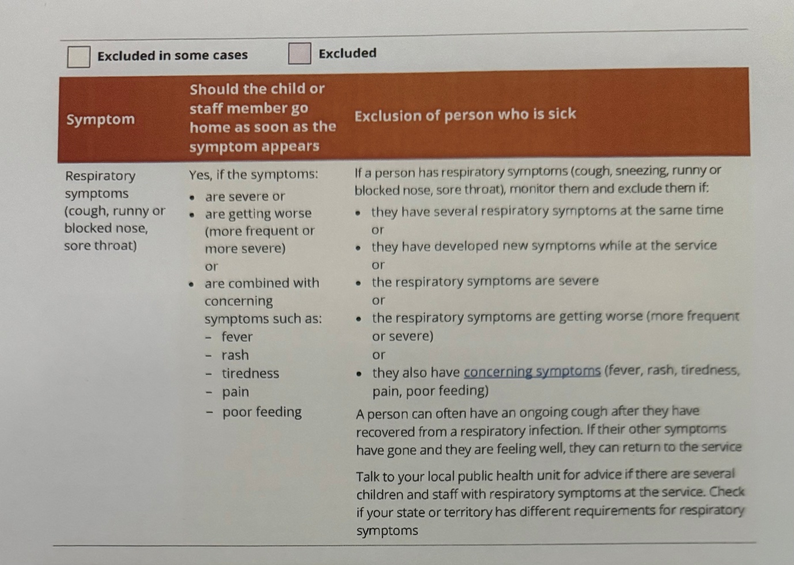
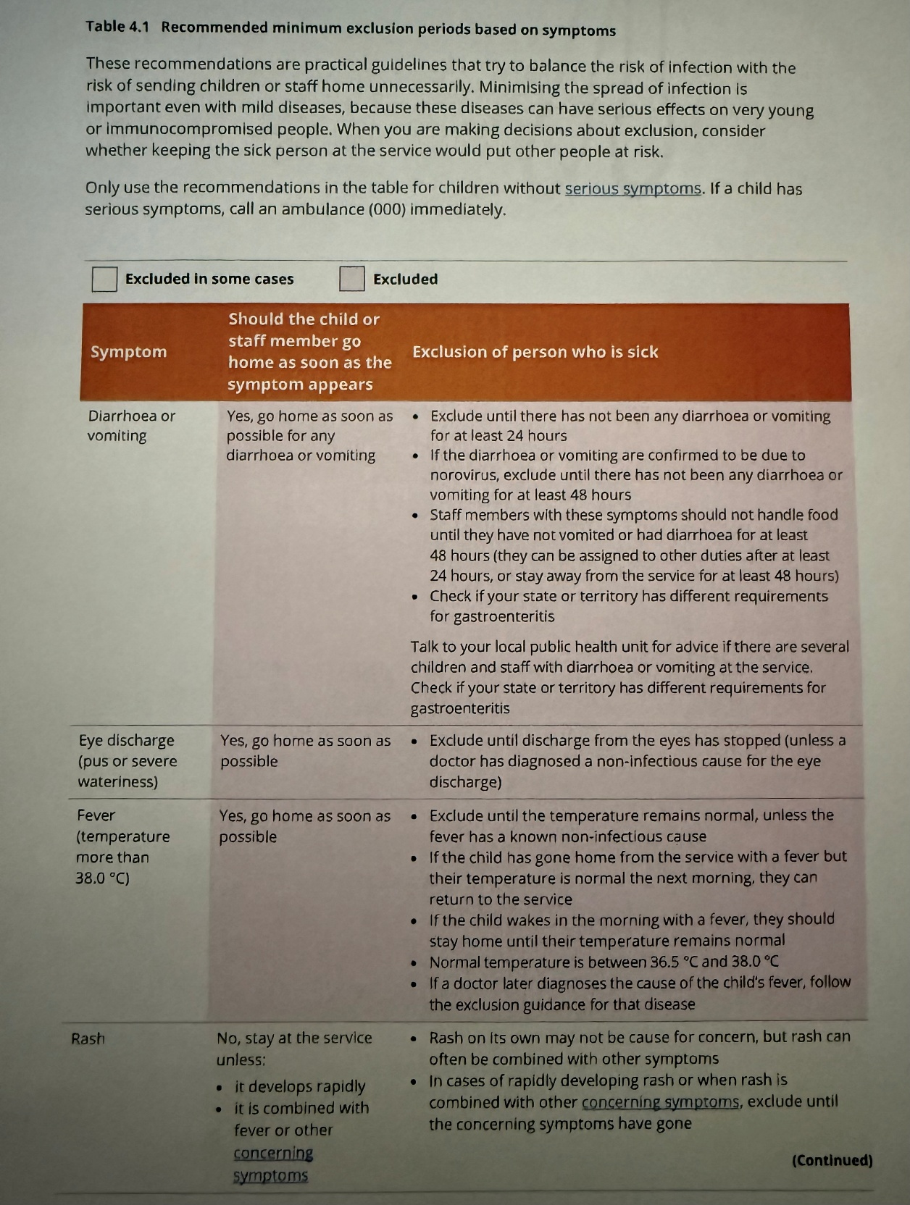
Our Place Preschool will follow the advice of NSW Health which can be found at WWW.health.nsw.gov.au
Health Direct
1800 022 222

